How to bind a different template

Binding Storageboot policy template:

Servers tab-🡪General tab from right side pane select unbind from the template from previous one (org-root/ls-WC-HETD). Keep monitoring untill overall Status comes back to OK.

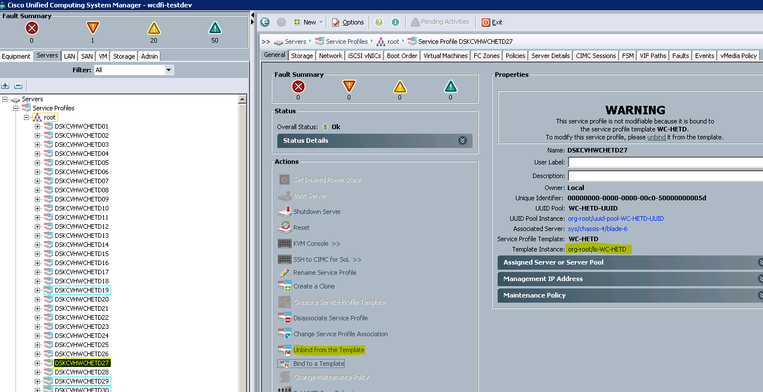

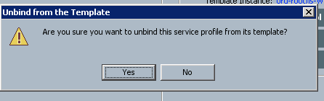

Than reboot ESXi it will boot from WC-HETD service template.

If OS is not installed we need to install ESXi , if you mapped new Boot LUN.

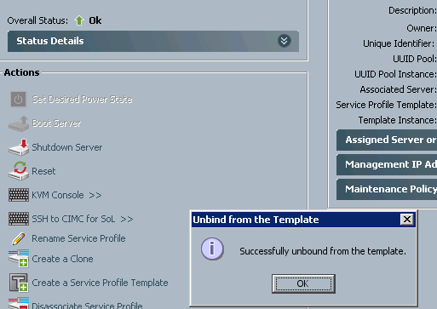

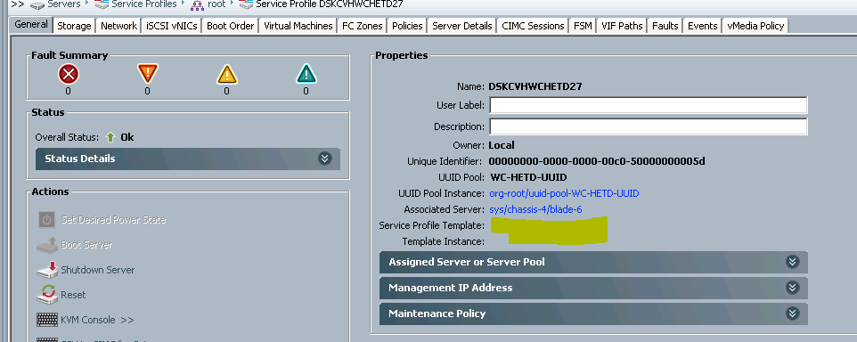

Now click on Bind to a Template

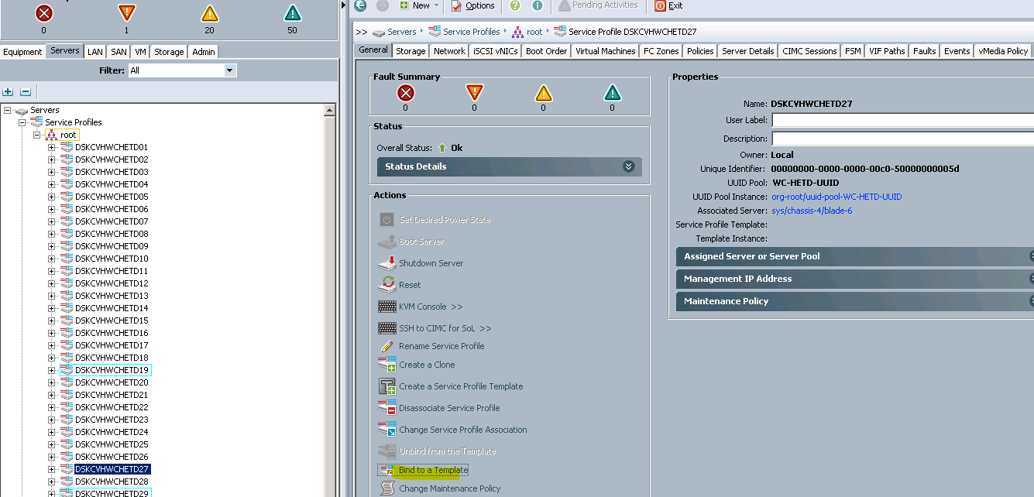

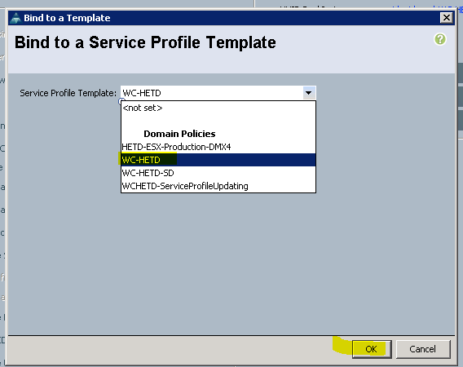

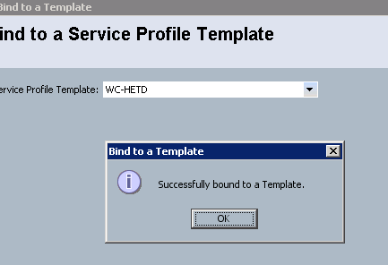

Now reboot ESXi

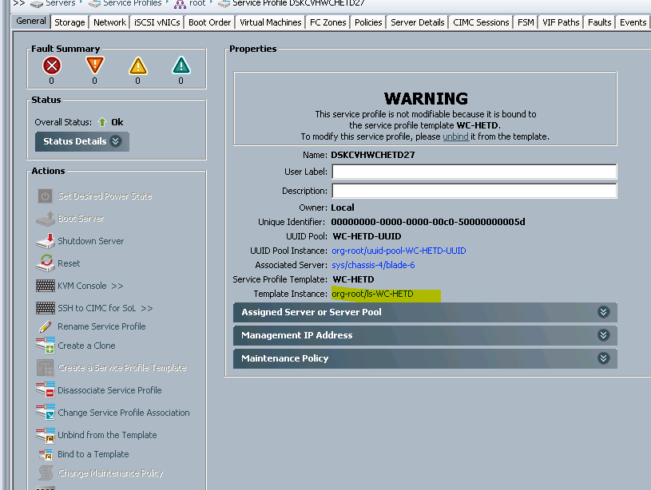

Here you ca check Boot either local or San.

